**LAB NAME** : AI ASSISTED CODING

**ROLL NO** :2503A51L29

**BRANCH** : CSE

**NAME** : k.shashikumar

**TASK 1**

**Task Description:** Introduce a buggy Python function that calculates the factorial of a number using recursion.  
Use Copilot or Cursor AI to detect and fix the logical or syntax errors.

**PROMPT:** In Above Code there is a bug can you identify and fix it, along with explanation.

**BUGGY CODE:**

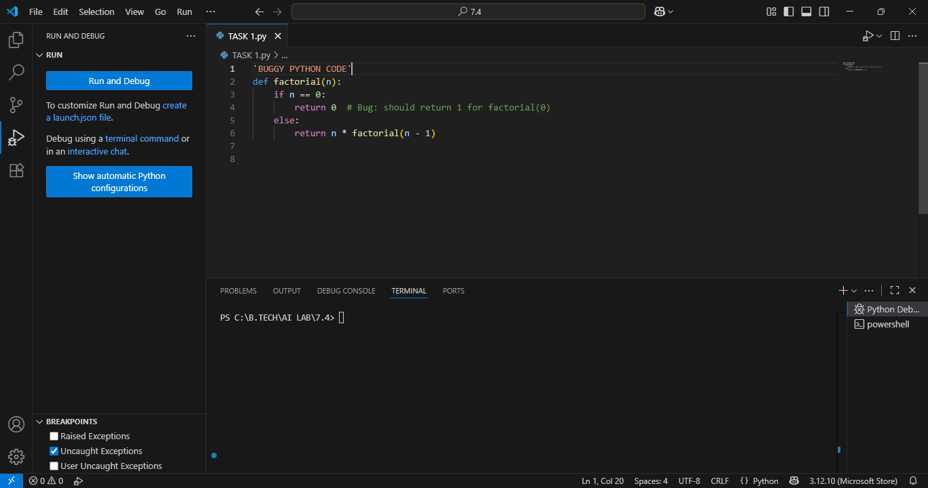

**WORKING CODE:**

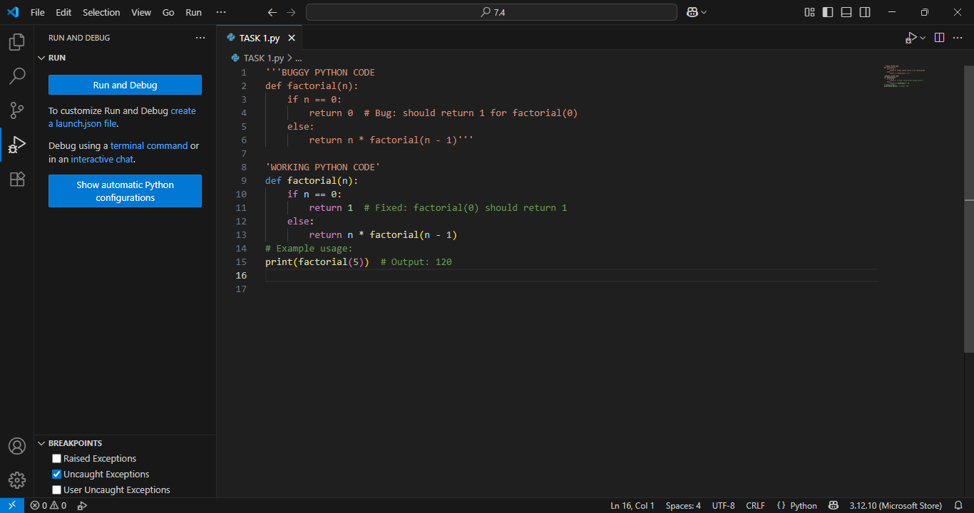

**OUTPUT:**

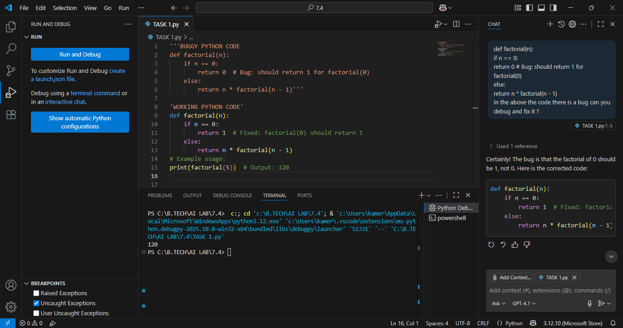

**TASK 2**

**Task Description #2:  
•** Provide a list sorting function that fails due to a type error (e.g., sorting list with mixed  
integers and strings). Prompt AI to detect the issue and fix the code for consistent sorting.

**PROMPT: :** In Above Code there is a bug can you identify and fix it, along with explanation.

**BUGGY CODE:**

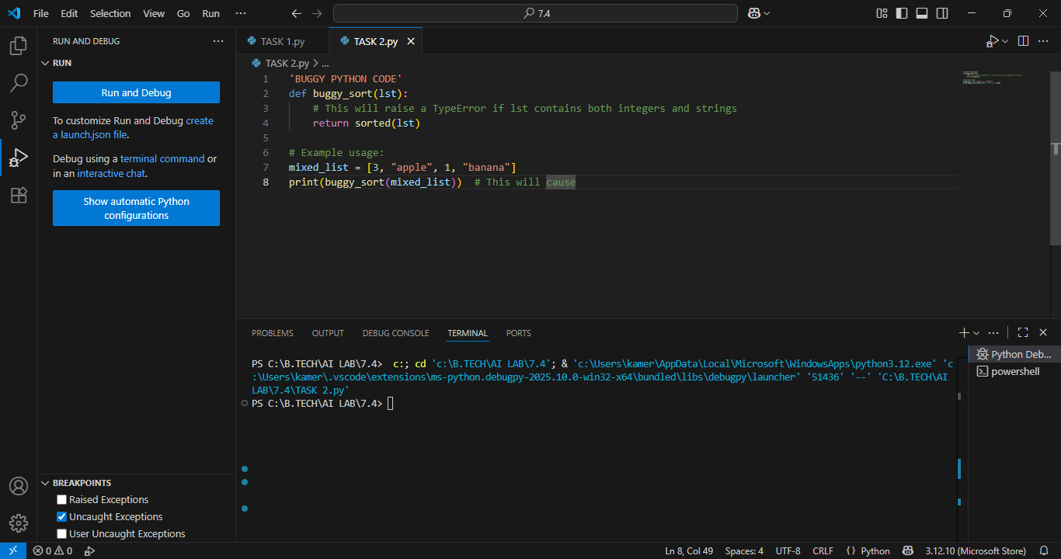

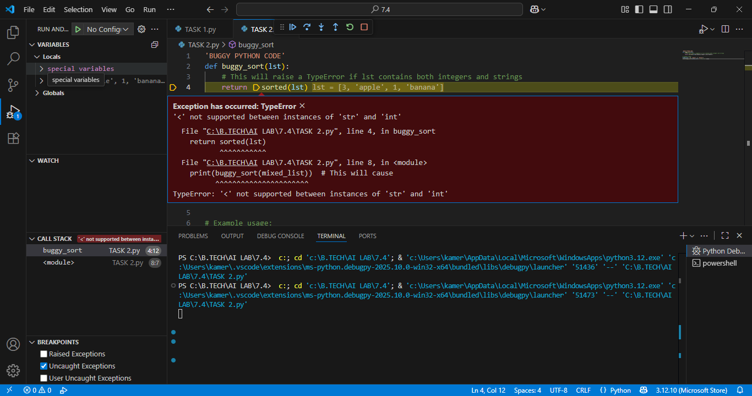

**WORKING CODE:**

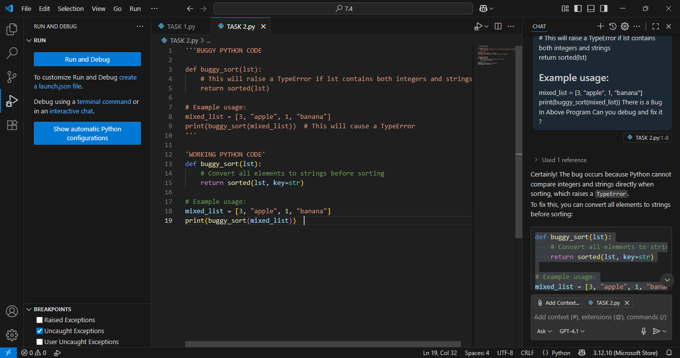

**OUTPUT:**

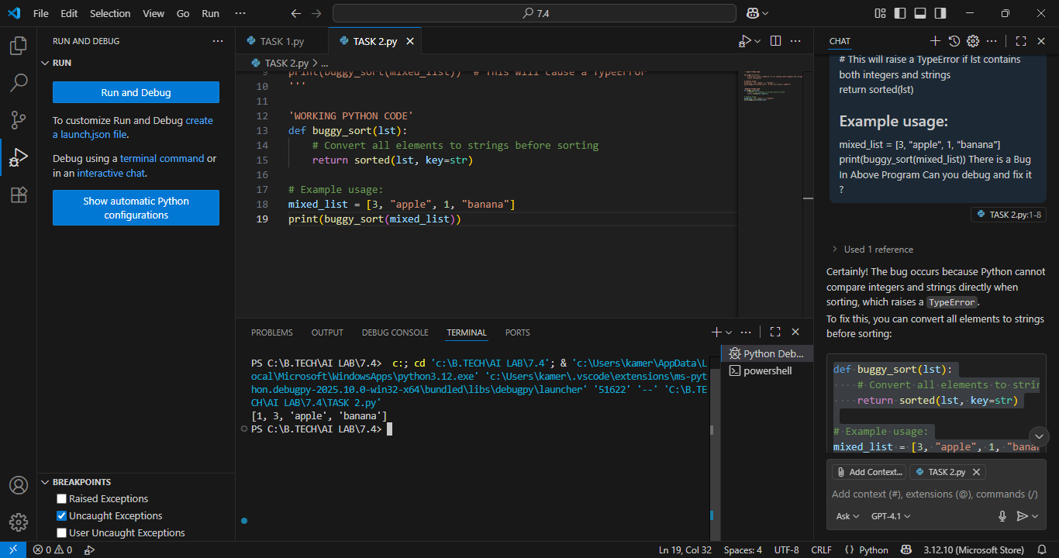

**TASK 3**

**Task Description #3:  
•** Write a Python snippet for file handling that opens a file but forgets to close it.Ask Copilot or Cursor AI to improve it using the best practice (e.g., with open() block).

**PROMPT: :** In Above Code there is a bug can you identify and fix it, along with explanation.

**BUGGY CODE:**

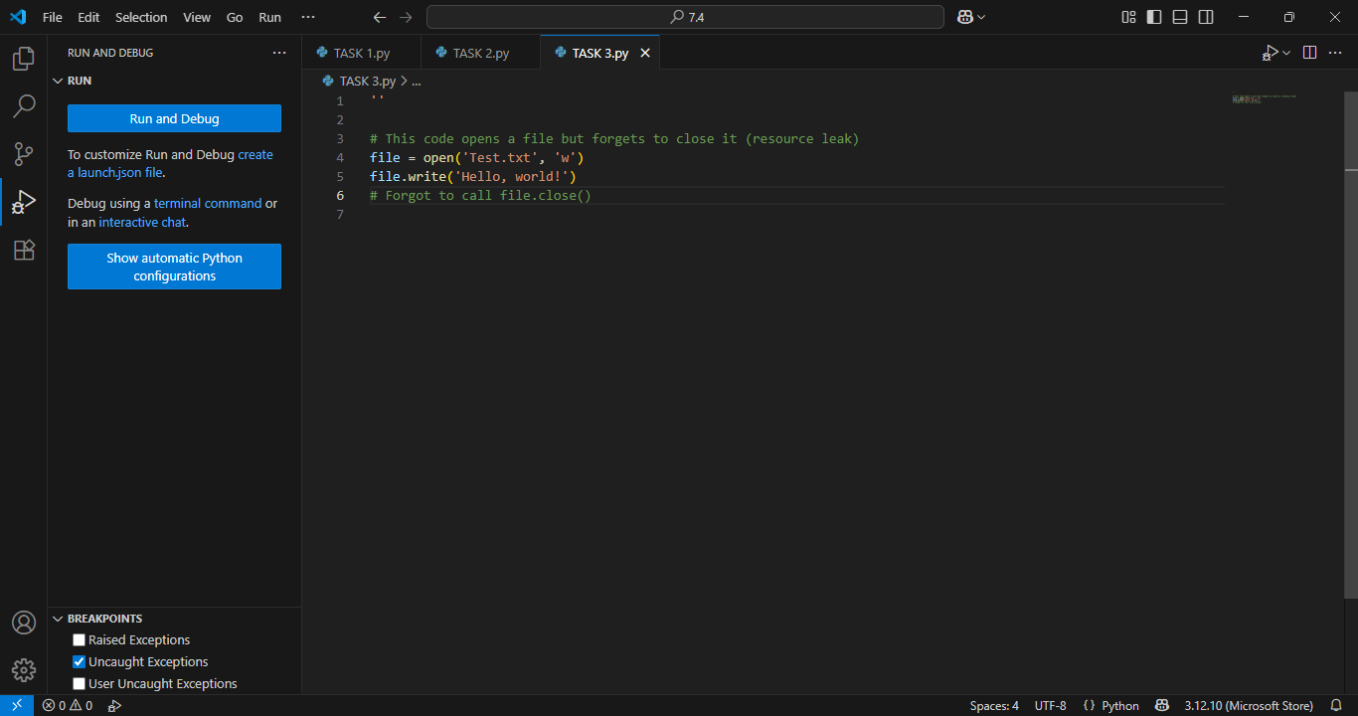

**WORKING CODE:**

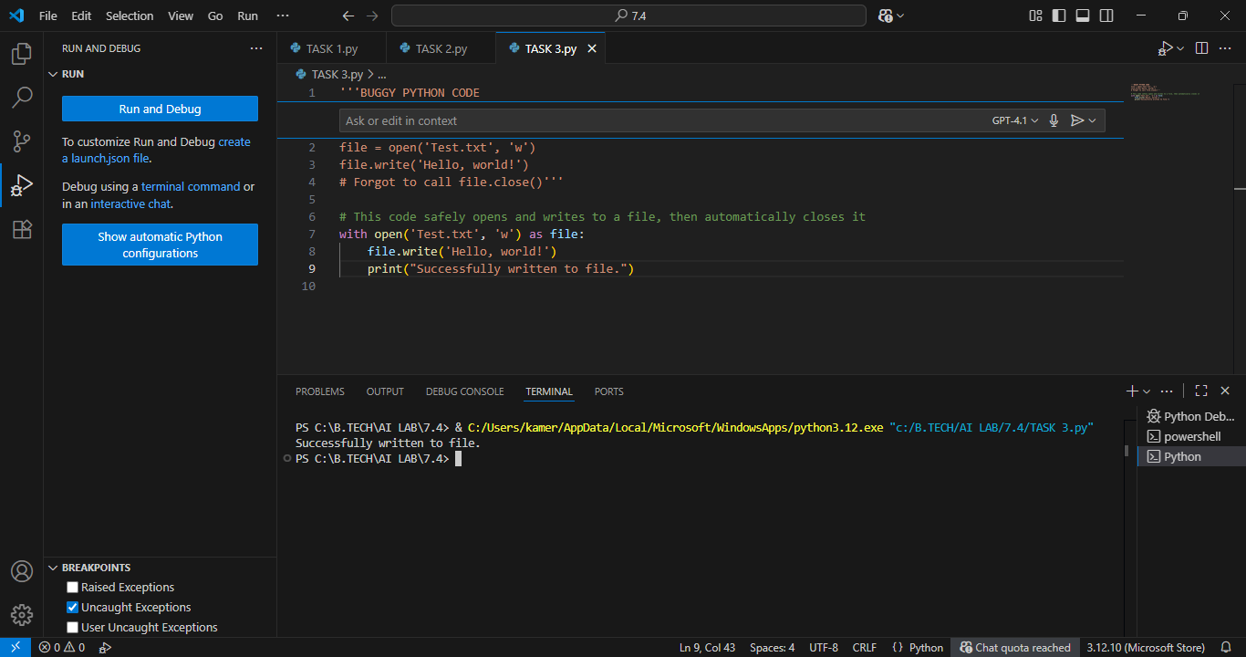

**OUTPUT:**



**TASK 4**

**Task Description #4:  
•** Provide a piece of code with a ZeroDivisionError inside a loop. Ask AI to add error handling using try-except and continue execution safely.

**PROMPT: :** In Above Code there is a bug can you identify and fix it, along with explanation.

**BUGGY CODE:**

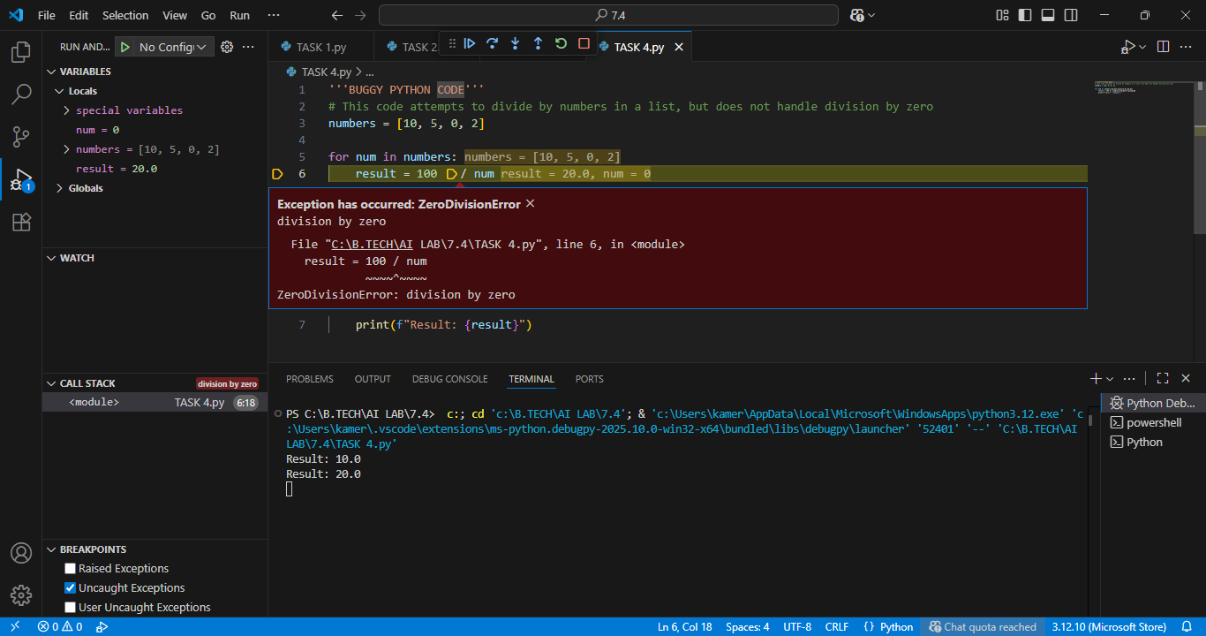

**WORKING CODE:**

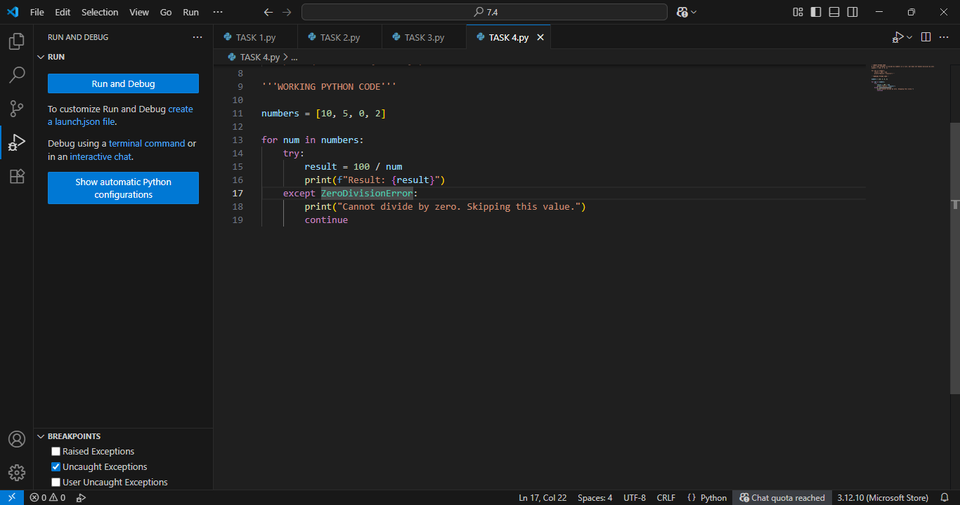

**OUTPUT:**

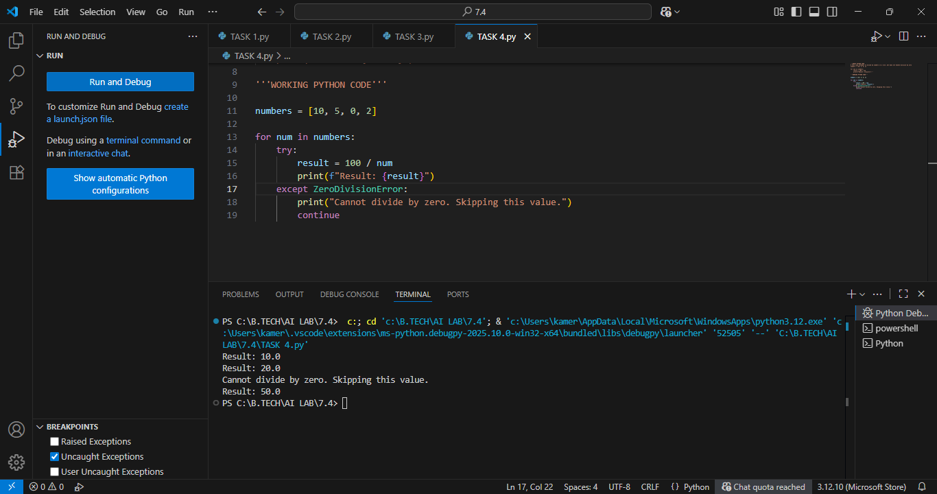

**TASK 5**

**Task Description #5:**• Include a buggy class definition with incorrect __init__ parameters or attribute references. Ask AI to analyze and correct the constructor and attribute usage

**PROMPT: :** In Above Code there is a bug can you identify and fix it, along with explanation.

**BUGGY CODE:**

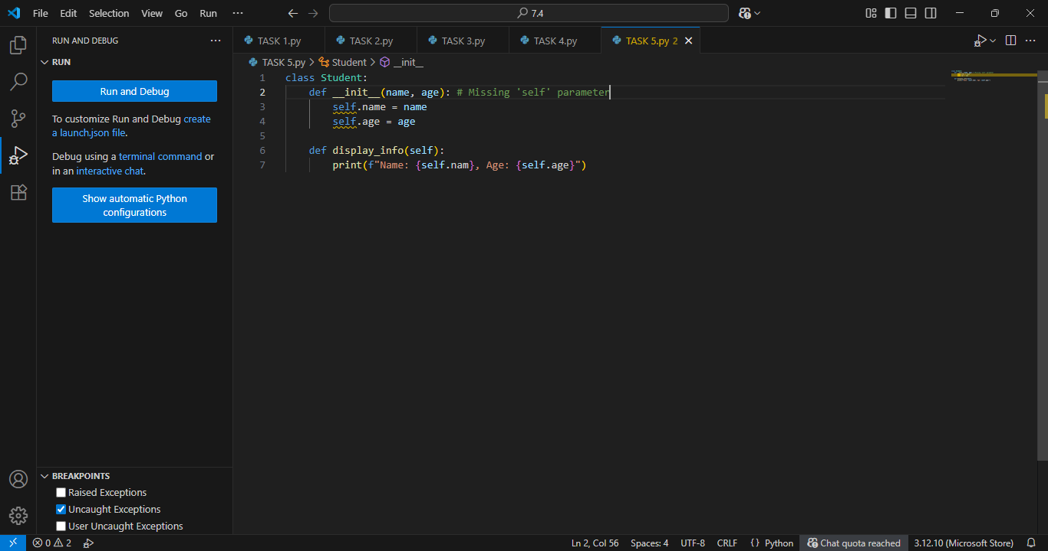

**WORKING CODE:**

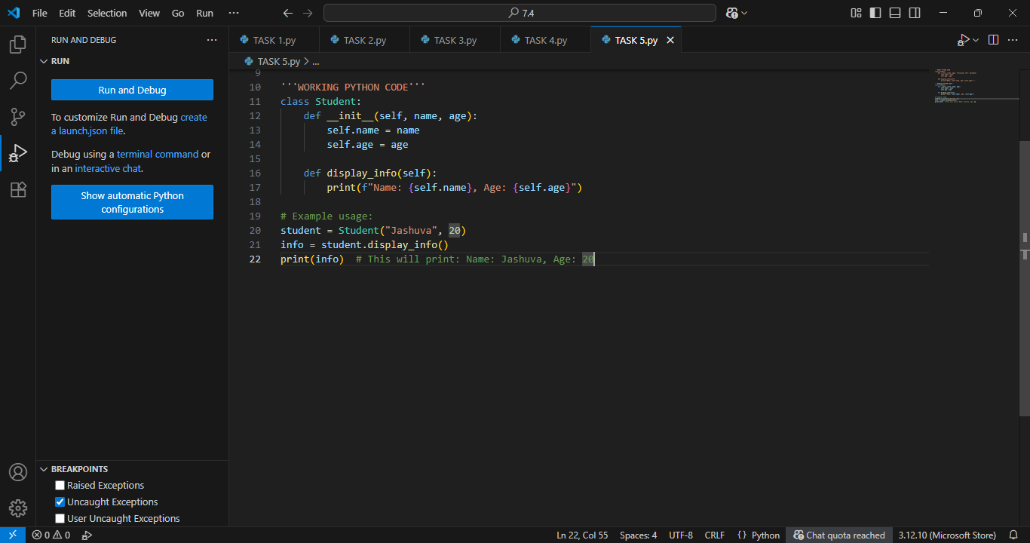

**OUTPUT:**

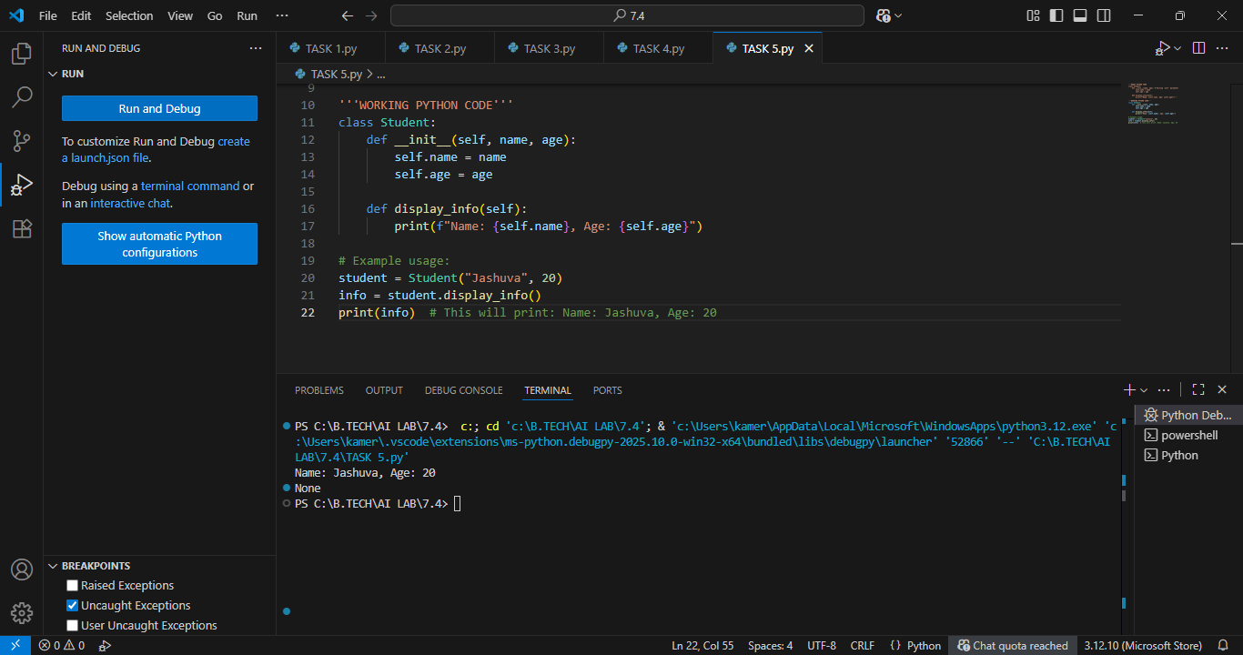

**OBSERVATION:**

I Observed that GitHub AI Copilot can easily generate the correct programs and identifying errors or Bugs in given program and it can easily debugging along with explanations. GitHub Copilot is a fascinating tool to observe—especially in how it transforms the developer experience.